|  |  |
| --- | --- |
| 1 | Abstract |
| 2 | Problem Definition |
| 3 | Business Requirement |
| **4** | Technical Requirement |
| **5** | Evolution Criteria |
| **6** | Limitations |

**1. Abstract**

We want to develop one online buying and selling portal for YASH employees, where all the employees can buy or sell any product inside the organization. The objective of this portal is to share the goods among employees and do the transaction.

Goods can be of various categories like household, electronic, vehicle, property etc. categories can be later added by the super admin of the application.

Initially we are planning the “**Cash On Delivery**” payment option, but application should have capability to incorporate other options in future.

**2. Problem Definition**

We want to develop a platform for all the YASH employees where if they wish then they can buy or sell the products. There should be a separate account for seller and for buyer. Seller should be able to track his **order management**, **payment management**, **product management**, **report management** etc.

Buyer should be able to track the **order status**, **history**, **payment** and **card management**, **report management** etc.

**3. Business Requirement**

* System will have mainly 4 type of users.

1. Visitor
   1. Visitors can view the products, visit the site, search products.
2. Registered Users - Buyers
   1. Registered users will be able to buy the products, they will be able to manage their cart. They will be having a separate dashboard where they can **manage order**, **profile**, **shipping address** etc.
3. Sellers
   1. Sellers will be users who will be **managing products** in their account, **order management**, **payment management** and **order shipping** will be managed by sellers.
4. Admin
   1. Management of the site will be in their hand. They can **add categories**, **payment** **options** or any dynamic nature in application that will be visible to all the sellers and buyers. Your application should be modular so that these options can be latter added.
   2. Admin will have the authority to accept or reject the product uploaded by seller.

* There should be a support for mail notification in the system wherever is required.
* **Buyer Operations**
* Visiting categories
  + - Registered or Guest buyer should be able to visit category options.
* View products and product detail
  + - Any user should be able to see the product and product detail
* View offers and discount on product
  + - Any user should be able to see the offers and discounts on product
* Coupons on purchase

Coupons can be of several types. Some will be provided on other sales for later use, some will be provided for promotional activities etc. it can be decided later how to provide coupons. Once coupons are applied closing price of the product will get reflected.

* Cart handling
  + - Registered user should be able to handle cart. He may update quantity, delete product, add the product in wish list. Etc.
* Today’s deal
  + - Today’s deal will be shown to visitors. Deal can be decided based on different criteria, like festive offer, occasion, special price. This will be decided by the admin.
* New arrival section
  + - New arrival section will display the newly added products.
* Wallet option [Optional - can be implemented once this product is ready for launch]
  + - Give this option to registered candidates, so that he can add the money in wallet, and if user pays from wallet, some coupons can be given to him that he can utilize for further purchase.
* Featured products
  + - Here those products will be displayed which is bought by many people. Or highly searched items.
* Track your order
  + - Buyer should be able to track their order.
* **Seller operations**
* Visiting Categories
* Visit the categories in order to add products in specific category.
* Add Product
* Only registered seller should be able to see the “ADD PRODUCT” option to add the products in his account.
* Form to add Product detail and Seller detail
* A form should be displayed to add the product detail including title, product description, price of the product , product image ( No. of image that can be posted must be limited to three image per product)
* Form should also contain seller detail option and all the required fields for the same
* Edit Or Delete Product
* Seller should be able to edit the product detail only in case admin has not approved the product for publish publically or he should be able to edit for the specific time period.
* Application level Notification
* Seller should get the notification on the dashboard once he logged in for the today’s orders.
* This will include all the necessary details of the buyers.
* Seller Account
* Seller should be able to view all the products that has been sold out by him.
* Order Management

It includes multiple steps that should be updated in the system to inform buyer about their product delivery :

* Accepting the order request
* Packaging of the product
* Product shipment
* Order delivered
* Payment Management
* Seller must be able to update payment status in the system( i.e. pending, received, etc)
* **Admin operations**
* Admin should be able to add the categories.
* Payment : Admin should be able to add more payment options when required
* Review uploaded products : Any product uploaded by a seller must be approved by admin before being posted on buyer’s page .
* Pages that will be designed in application

**For Buyer**

* Home page

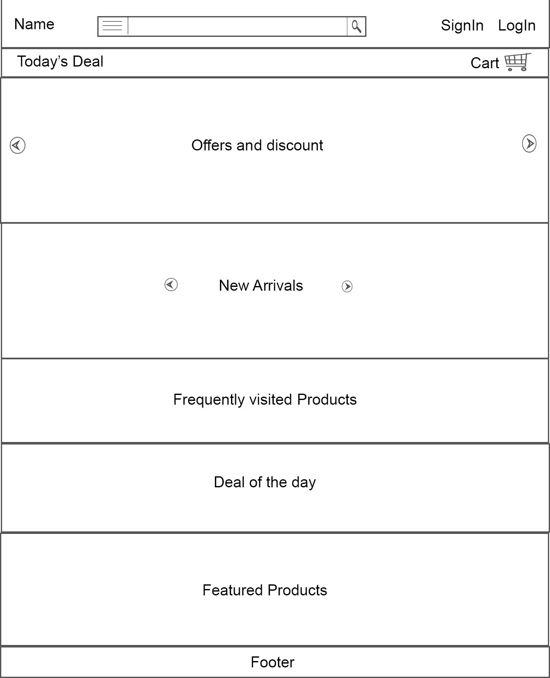

* Login

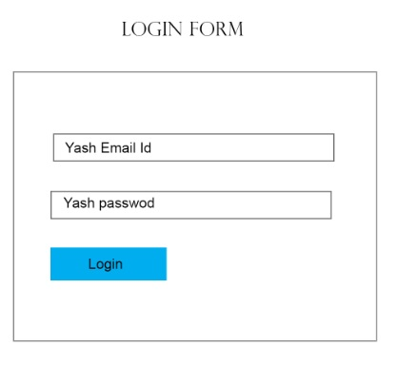

* Sign in

Fields required for registration are :

1. Yash Email Id
2. Yash Password
3. Type Of User : It should be a drop down having two options .i.e. Buyer and Seller.

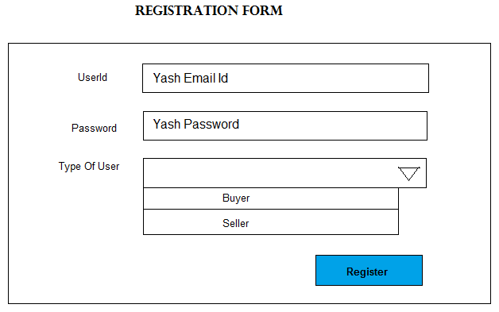

* Your orders - Buyer

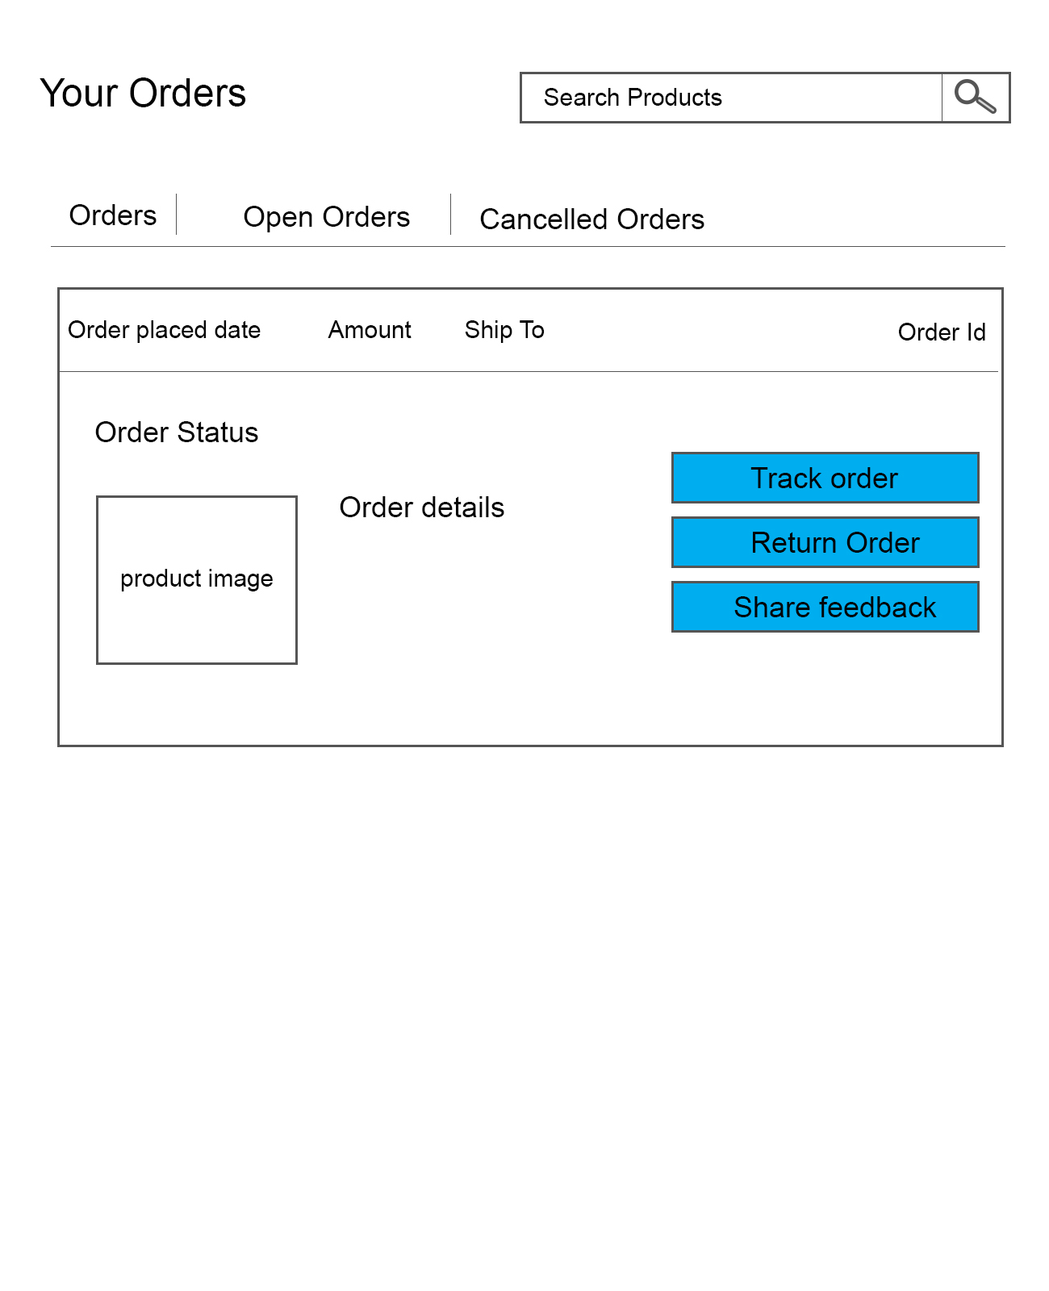

* Your cart - Buyer

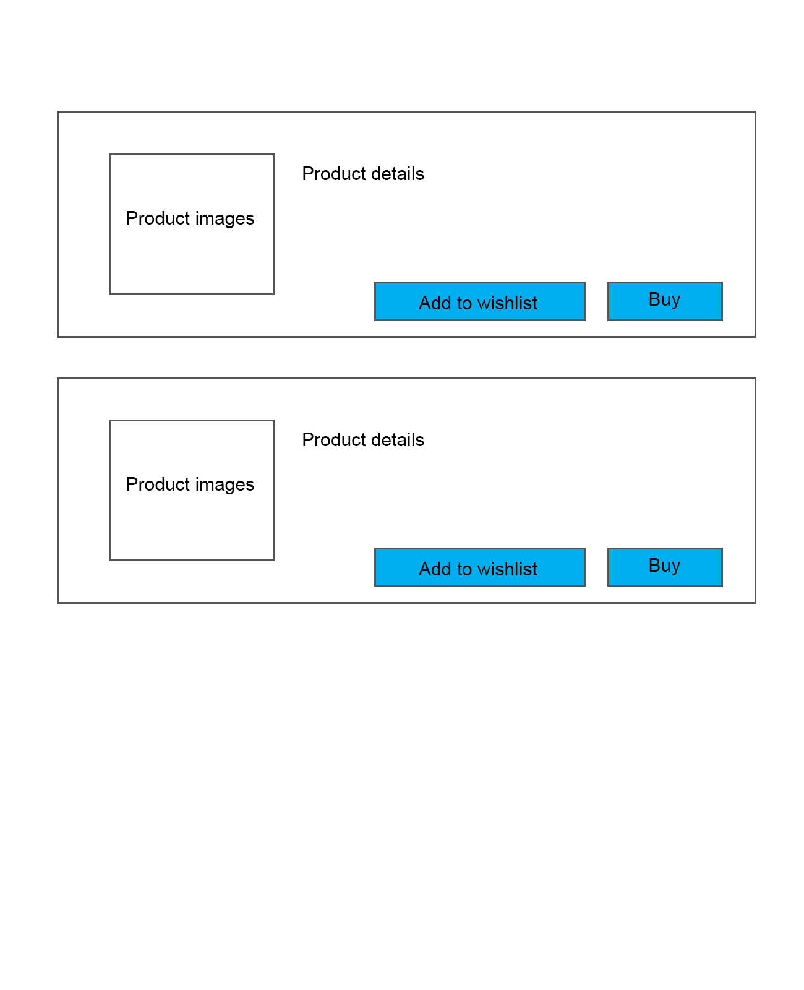

* Visit Categories - Buyer

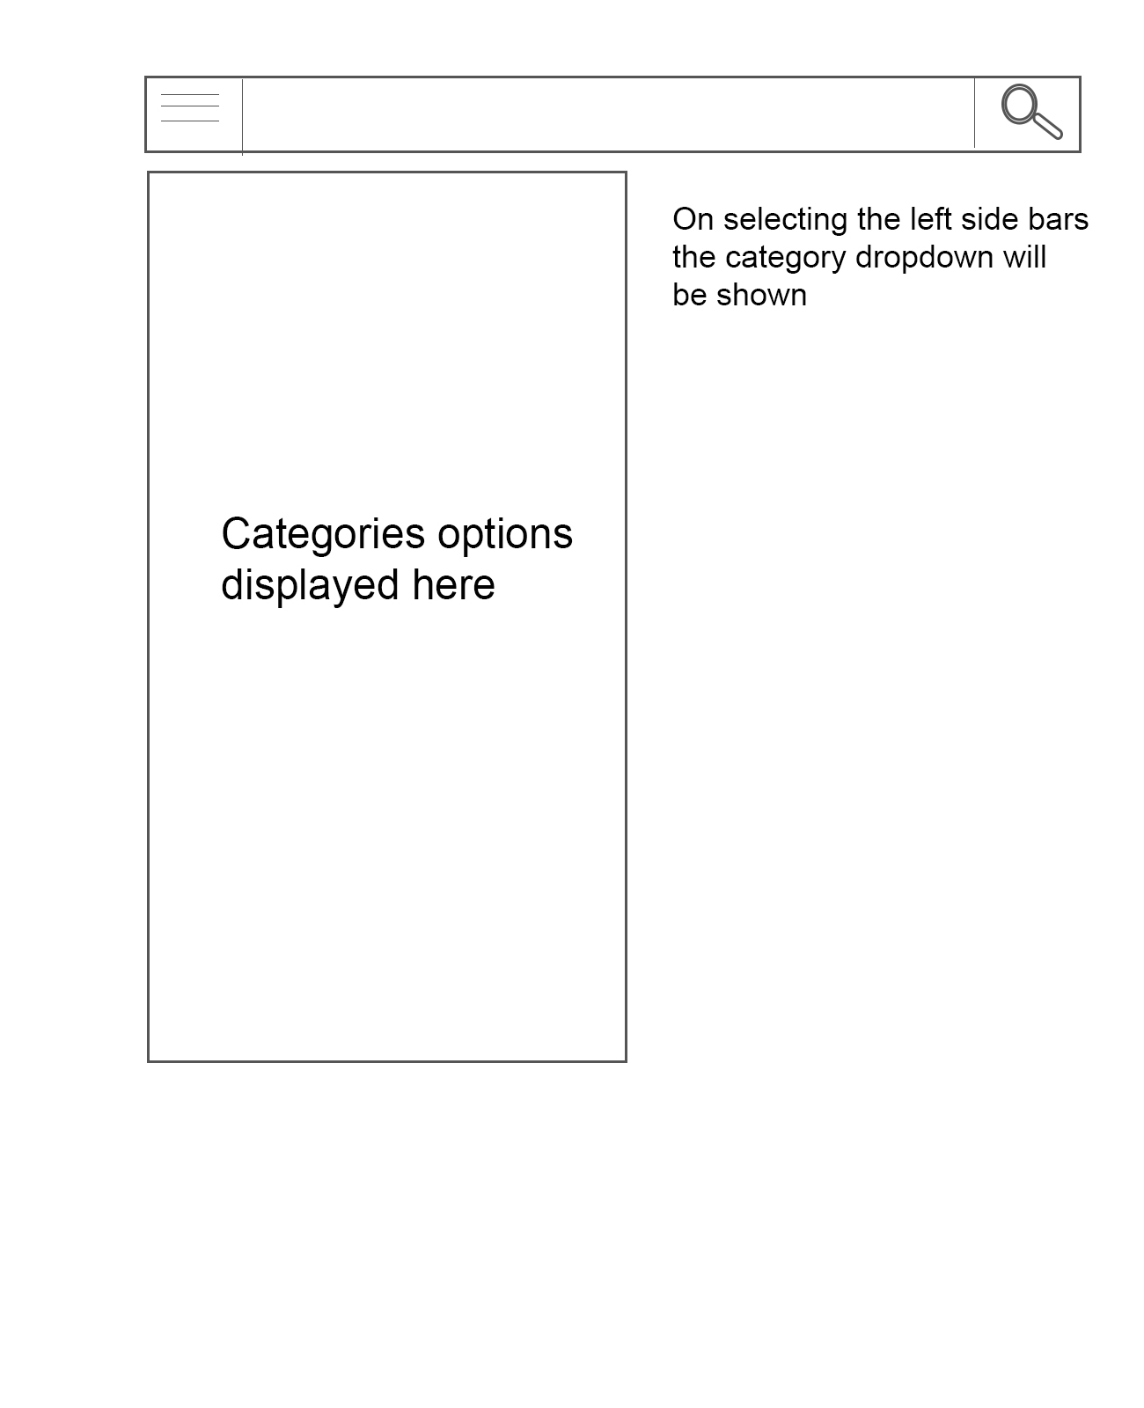

* View Product – Buyer

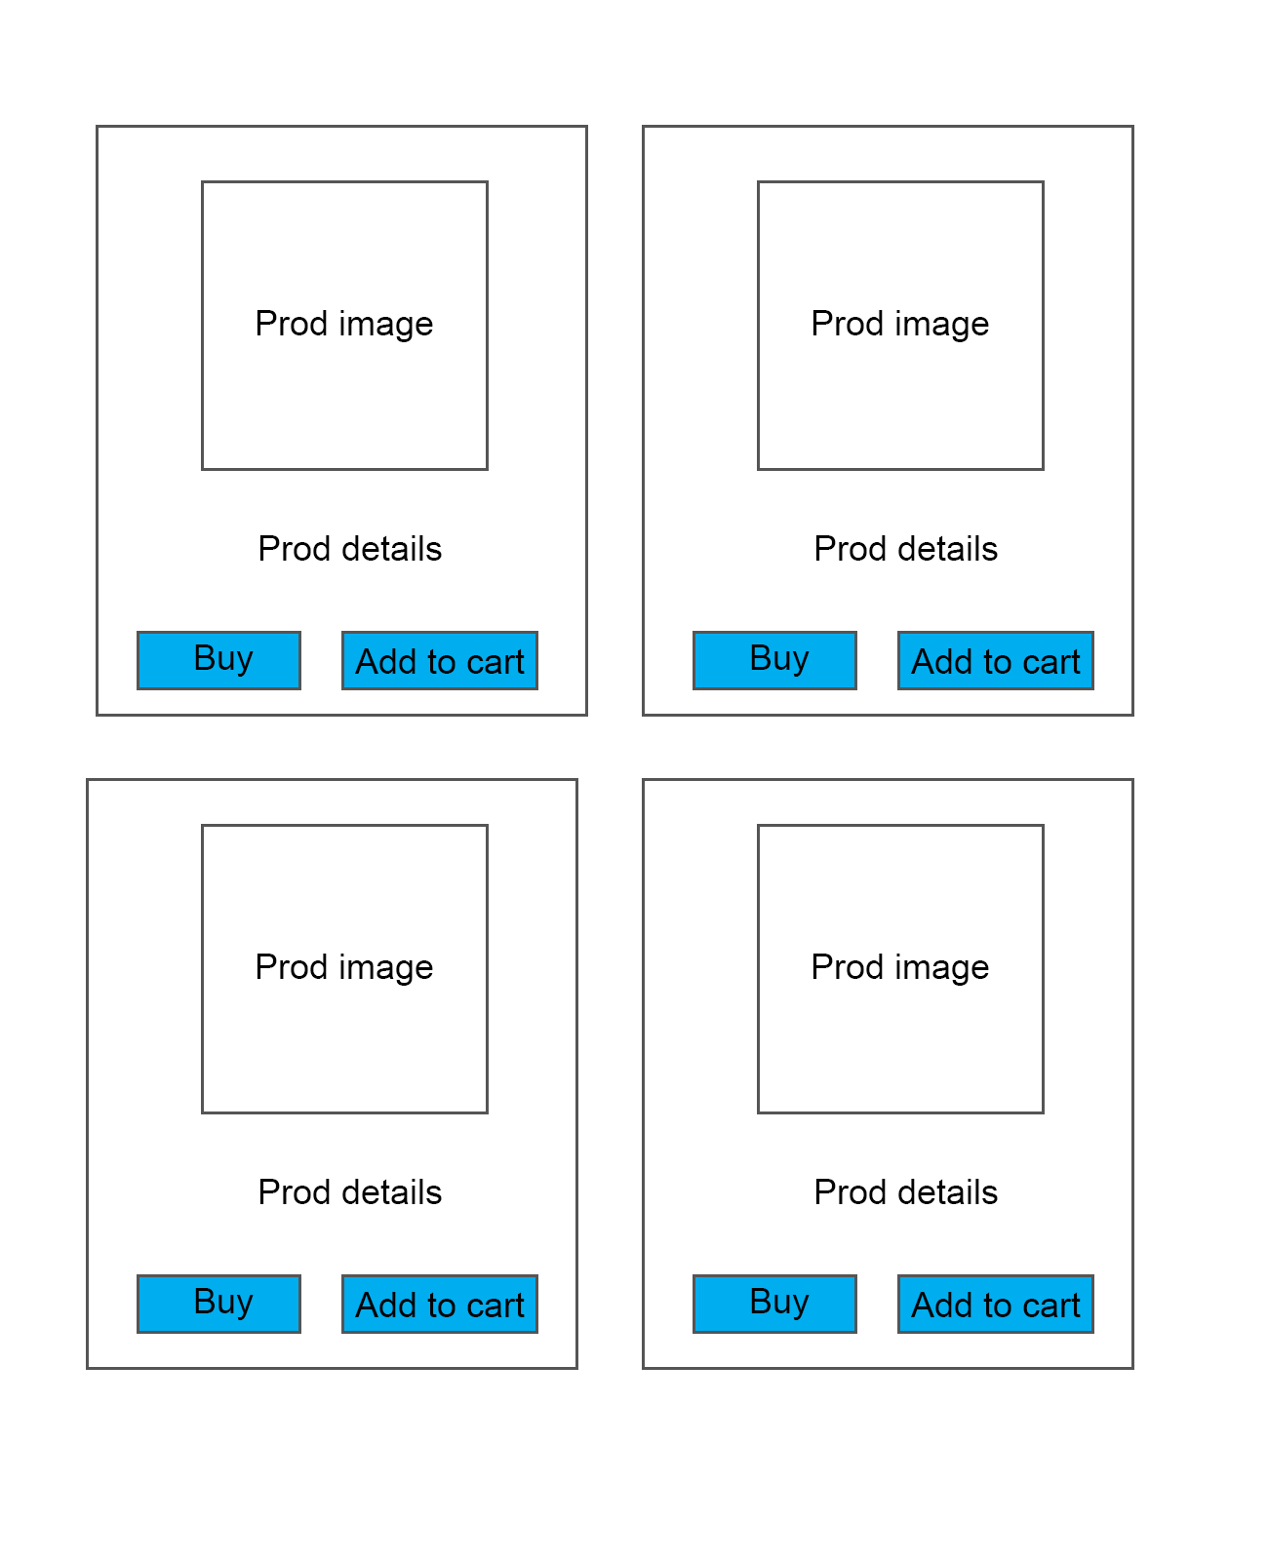

* Offers – Registered user

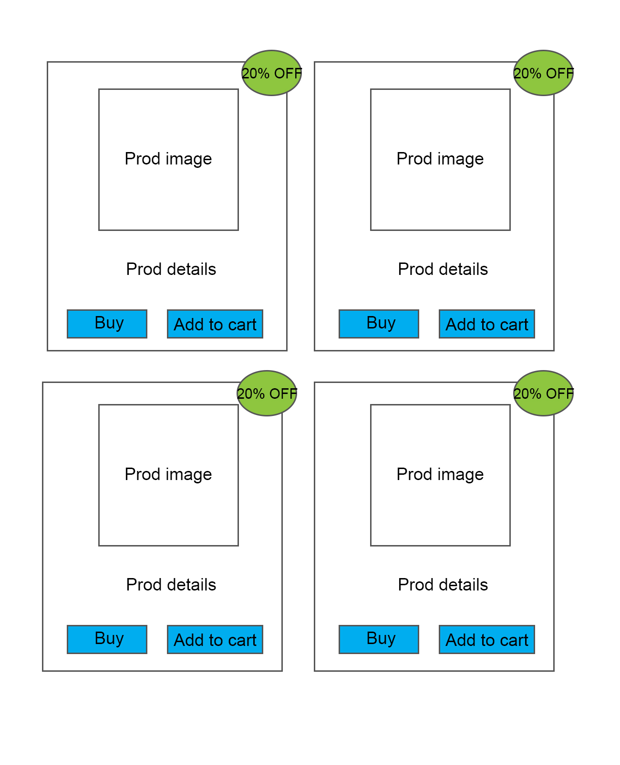

* Track your order - Buyer

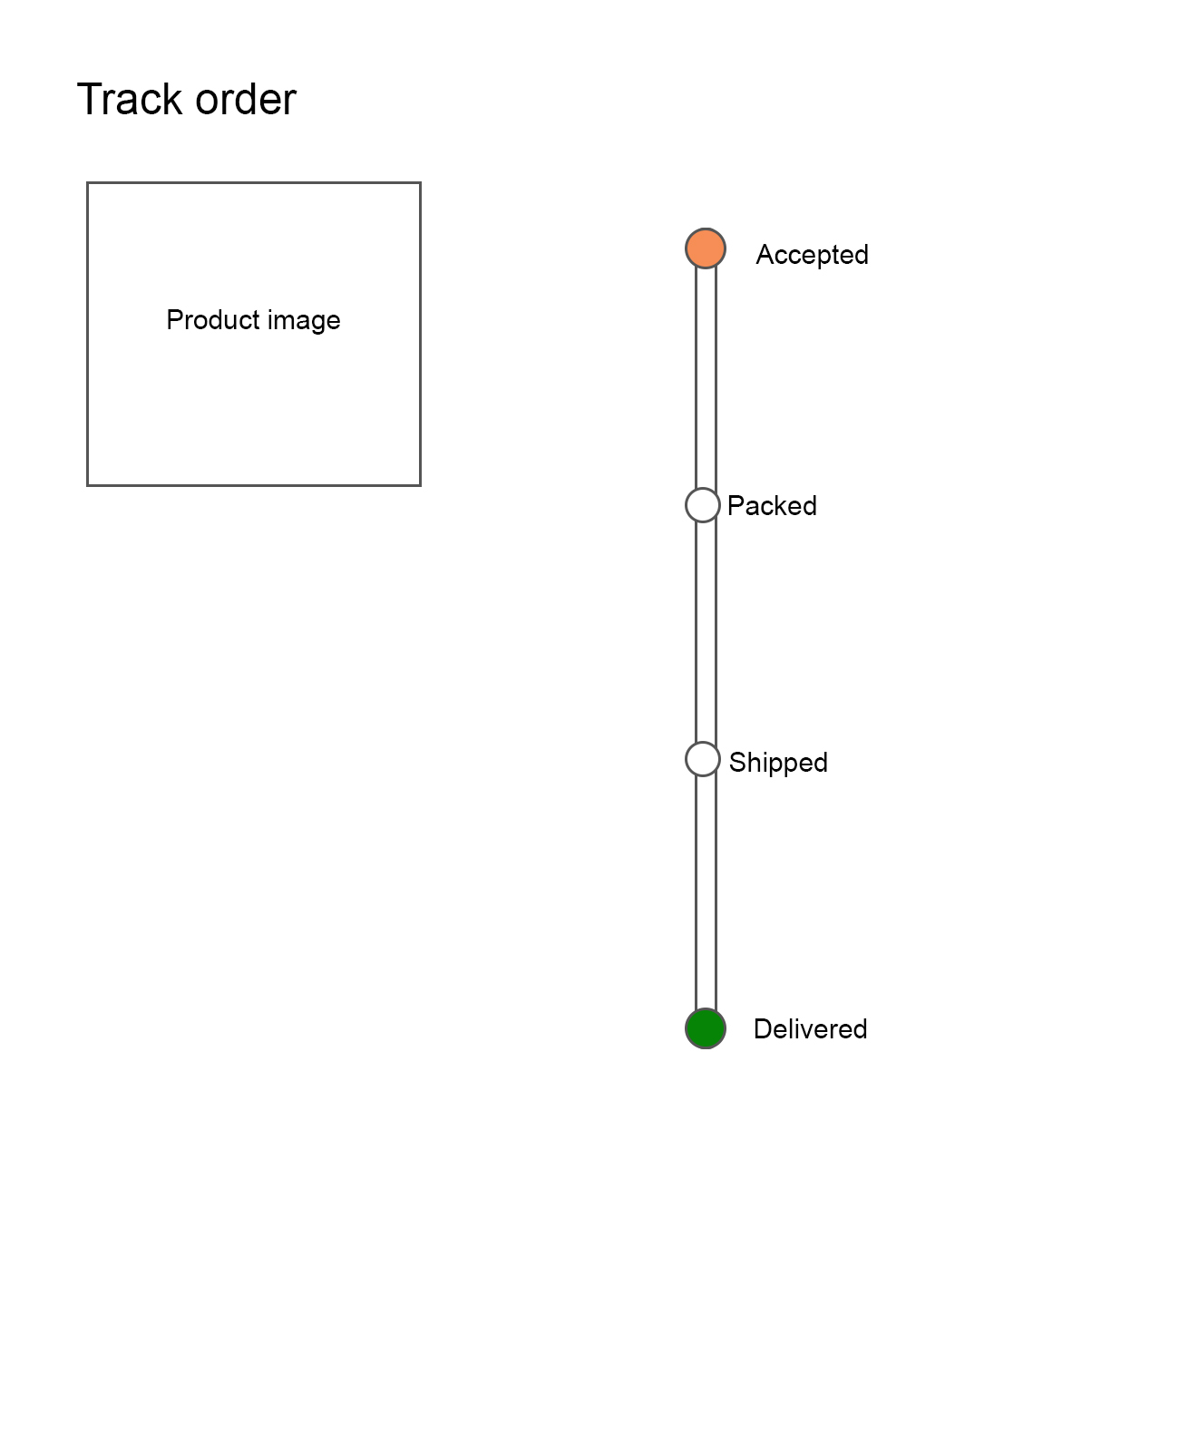

* Your wish list – Buyer
* Your account – Buyer

**For Seller**

* Sold out products - Seller
* Updating order status - Seller

**For Admin**

* Add Categories - Admin
* Assigning role - Admin
* Approve or reject product - Admin

**Technical Requirement**

* Application must be single page application
* On front end use React and Redux concept - it should be a separate project for presenting the presentation layer
* Both client side and server-side validation need to be managed properly.
* Use spring jdbc for data persistence.
* Use Spring 4.x, and you need to develop a project by using annotation only approach.
* Application has to be developed on micro service architecture, where core module will be separate, Admin module will be separate, seller and buyer modules should be separate.
* All the respective Rests URIs should be on common place.
* Use logging wherever it is required
* The whole application must be developed using test first approach. Test cases on each level are mandatory.

**Evaluation Criteria**

* Modular Approach should be used in application development
  + Class level
  + Method Level
* Should make use of oops concept in appropriate situations.
* Should make use of oops principles in whole application.
* Should be using all clean code principles.
* Application code should be reusable
* Application code should be well testing using Junit and Mockito
* Appropriate names should be used for class, interface, method, variables, tables and columns
* Small method size, not more than 20 to 25 lines.
* User-friendly interface
* Accuracy of calculation
* Timeline delivery
* Completion status